Predictive Maintenance Machine Failure Classification

Prepared by: Mohamed Hamzawi
Project Type: Machine Learning / Industrial AI
Dataset: AI4I 2020 Predictive Maintenance Dataset
Date: June 2026

Table of Contents

1. Abstract 3
2. Problem Statement 3
3. Dataset description 4
4. Exploratory Data Analysis 5
4.1. Target Distribution 5
4.2. Failure Type Distribution 5
4.3. Feature Analysis 5
4.31. Air temperature 5
4.32. Torque distribution 6
4.33. Tool Wear 6
4.4. Correlation Matrix 6
5. Feature Engineering 7
6. Preprocessing and pipeline design 7
7. Model training 8
8. Evaluation results 8
8.1. Before hyperparameter tuning 8
8.2. After hyperparameter tuning 8
9. Threshold selection 9
10. Inference and deployment 9
11. Limitations 10
12. Future work 10
13. Conclusion 10

1. Abstract
This project aims to predict machine failure using sensor and operational data from the AI4I 2020 predictive maintenance dataset.
The problem was treated as a binary classification task, where the target variable indicates whether a machine will fail or not. The workflow included exploratory data analysis, feature engineering, preprocessing, model training, threshold tuning, and error analysis.
Several machine learning models were compared, including Logistic Regression, Random Forest, and Extra Trees. Since machine failure cases are rare, precision-recall metrics were prioritized over accuracy. The final model was packaged into a reusable pipeline and prepared for inference on new machine readings.

2. Problem Statement
In industry, predictive maintenance plays a crucial role in increasing productivity and efficiency of production by reducing machine downtime and reducing repair cost. Our model aims to detect potential equipment failures before they occur. Instead of waiting for a machine to fail, sensor readings and operational data can be analysed to estimate the risk of failure. This allows maintenance teams to take earlier action, reduce downtime, and improve reliability.
In this project, the task is formulated as a binary classification problem. Given machine operating conditions such as temperature, rotational speed, torque, tool wear, and machine type, the model predicts whether the machine will fail or not.

3. Dataset description

Column | Meaning | Type | Unit
Type | Machine quality/type category | Categorical | L/M/H
Air temperature [K] | Ambient air temperature | Numerical | Kelvin
Process temperature [K] | Process operating temperature | Numerical | Kelvin
Rotational speed [RPM] | Machine shaft speed | Numerical | RPM
Torque [NM] | Applied torque | Numerical | Newton Meter
Tool wear [min] | Accumulated tool usage time | Numerical | Minutes
Machine failure | Target variable | Binary | 0/1

The dataset contains machine operating conditions and failure labels. The target variable is Machine failure, where 1 indicates that a failure occurred and 0 indicates normal operation. The dataset is imbalanced, meaning that normal cases are much more frequent than failure cases. Because of this imbalance, accuracy alone is not a reliable evaluation metric.
The dataset also includes specific failure mode columns such as tool wear failure, heat dissipation failure, power failure, overstrain failure, and random failure. However, the main target used in this project is the binary Machine failure column.

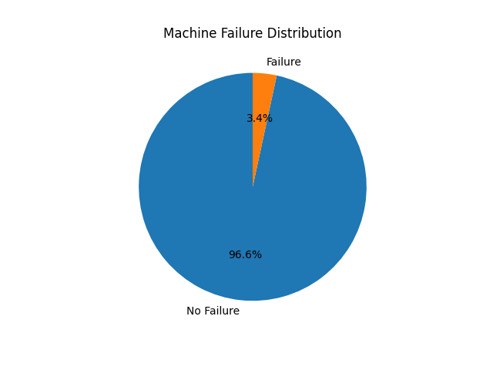
4. Exploratory Data Analysis

4.1. Target Distribution
The target distribution showed that machine failure cases are much less frequent than normal operating cases. This confirms that the problem is imbalanced classification. As a result, accuracy was not used as the main metric because a model could achieve high accuracy by mostly predicting the majority class.

4.2. Failure Type Distribution
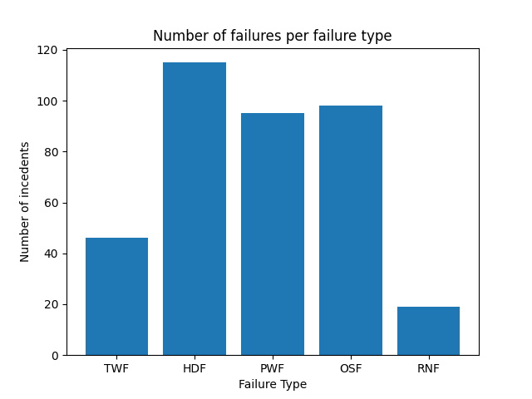
It can be noticed that Heat dissipation related issues cause the most failures.

4.3. Feature Analysis

4.31. Air temperature
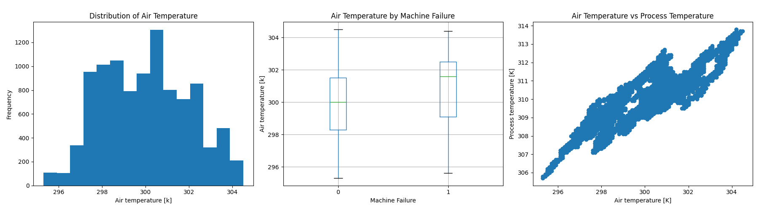
Air temperature is the ambient temperature of the air around the machine. It’s values are normally distributed between 295K and 305K. We can notice from the middle plot that Machine failure happens at higher slightly higher temperatures. We can notice from the plot on the right that there is a positive correlation between air temperature and process temperature.

4.32. Torque distribution
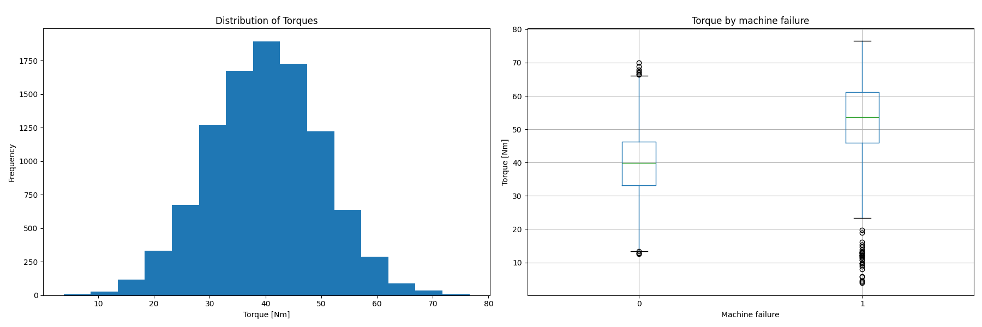
Torque is the feature representing the magnitude of mechanical resistance on the tool . It is normally distributed with its peak at 40 Nm. We notice from the right plot that machine failures tend to happen at higher torques, because the higher the mechanical resistance on the tool the higher the chance of failure.

4.33. Tool Wear
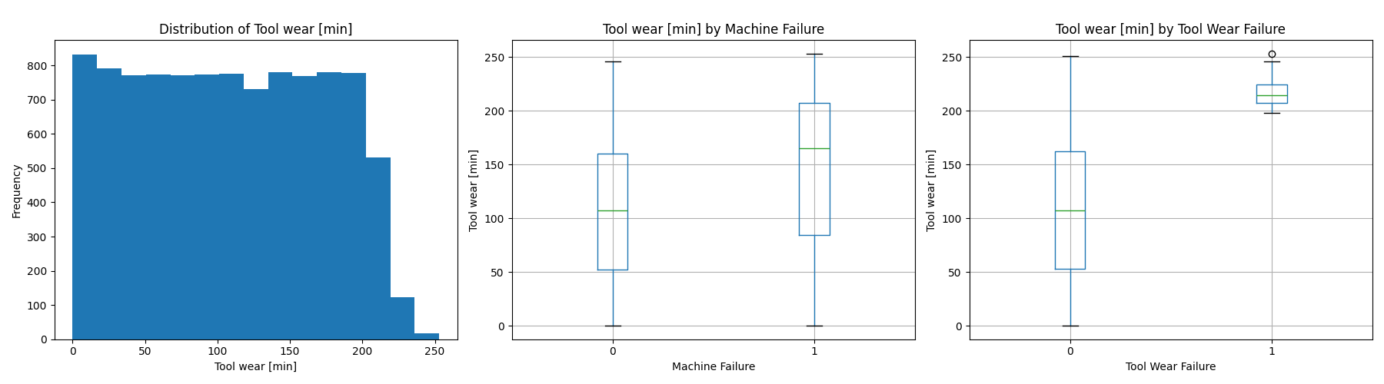We can notice that the higher the Tool wear the higher the probability of machine failure

4.4. Correlation Matrix
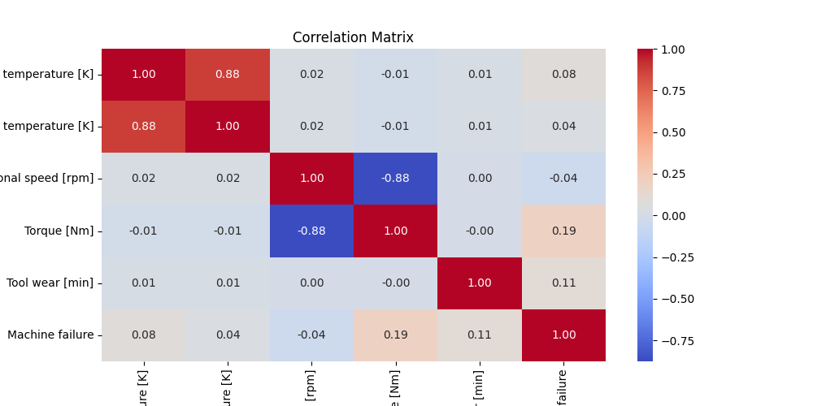

5. Feature Engineering
Engineered Feature | Formula / Idea | Reason
Temperature difference | Process temperature – Air temperature | Captures heating effect
Power | Torque * rotational speed | Represents mechanical load
Torque-Wear interaction | Torque * Tool wear | Captures combined stress and aging

Feature engineering was applied to create additional variables that better represent machine behavior. The temperature difference feature was created to capture the gap between process temperature and ambient air temperature. A power-related feature was created using torque and rotational speed to represent the mechanical load on the machine. In addition, a torque-wear interaction feature was created to capture the combined effect of mechanical load and accumulated tool usage.
To avoid training-serving mismatch, feature engineering was later moved inside the machine learning pipeline using a FunctionTransformer. This ensures that the same feature engineering steps are automatically applied during both model training and future inference.

6. Preprocessing and pipeline design
The preprocessing pipeline handled numerical and categorical features separately. Numerical features were scaled using StandardScaler, while the categorical Type feature was encoded using OneHotEncoder. The preprocessing stage was combined with feature engineering and the machine learning model inside a single Scikit-learn Pipeline.

Failure probability
Machine learning model
Numerical scaling + categorical encoding
Threshold-based prediction
Feature engineering
Raw input data

7. Model training
Model | Reason for trying
Logistic Regression | Simple baseline model, interpretable
Random Forest | Nonlinear tree-based, handles feature interactions
Extra Trees | Ensemble model with more randomness, useful for comparison

The models were evaluated using stratified cross-validation to preserve the percentage of failure and non-failure cases in each fold. This is important because the dataset is imbalanced.
Since machine failure is a rare event, PR-AUC was prioritized over accuracy. Precision, recall,
F1-score, ROC-AUC, and confusion matrices were also used for evaluation.

8. Evaluation results

8.1. Before hyperparameter tuning
Model | Precision | Recall | F1_score | ROC_AUC | PR_AUC
Logistic Regression | 0.153846 | 0.823529 | 0.259259 | 0.920838 | 0.434578
Random Forest | 1 | 0.661765 | 0.79646 | 0.97439 | 0.854503
Extra Trees | 1 | 0.514706 | 0.679612 | 0.962931 | 0.79446
These are the baseline model results with no hyperparameter tuning
The results showed that tree-based models performed better than the linear baseline. This suggests that the relationship between sensor readings and machine failure is nonlinear. PR-AUC was used as the main comparison metric because it focuses more on performance for the minority failure class.

8.2. After hyperparameter tuning
Model | Precision | Recall | F1_score | ROC_AUC | PR_AUC
Tuned Random Forest | 0.923077 | 0.705882 | 0.80 | 0.981299 | 0.882727

Hyperparameter tuning did not significantly improve PR-AUC compared with the baseline Random Forest model. This suggests that the default model was already capturing most of the useful patterns in the dataset, or that the dataset size and feature information limited further improvement.

9. Threshold selection
The model produces a probability of machine failure. By default, classification models often use a threshold of 0.5, where probabilities above 0.5 are classified as failure. However, in predictive maintenance, missing an actual failure can be more costly than raising a false alarm. Therefore, the threshold was adjusted to improve recall while keeping precision at an acceptable level.
After iterating over multiple threshold values and comparing the PR-AUC results, the selected threshold was 0.30 because it provided a better balance between recall and precision for the maintenance use case. It also happened to provide the best F1 score we have achieved so far
Model | Threshold | Precision | Recall | F1 Score | ROC-AUC | PR-AUC
Tuned Random Forest | 0.3 | 0.897959 | 0.862745 | 0.88 | 0.981299 | 0.882727
Tuned Random Forest | 0.35 | 0.913043 | 0.823529 | 0.865979 | 0.981299 | 0.882727
Tuned Random Forest | 0.25 | 0.846154 | 0.862745 | 0.854369 | 0.981299 | 0.882727
Tuned Random Forest | 0.4 | 0.928571 | 0.764706 | 0.83871 | 0.981299 | 0.882727
Tuned Random Forest | 0.2 | 0.8 | 0.862745 | 0.830189 | 0.981299 | 0.882727
Tuned Random Forest | 0.45 | 0.925 | 0.72549 | 0.813187 | 0.981299 | 0.882727
Tuned Random Forest | 0.5 | 0.923077 | 0.705882 | 0.8 | 0.981299 | 0.882727
Tuned Random Forest | 0.15 | 0.721311 | 0.862745 | 0.785714 | 0.981299 | 0.882727
Sorted by F1 score. I decided I must choose a threshold such that the minimum acceptable recall is 0.80. The best threshold for these criteria is 0.30
Lowering the threshold increased the model’s ability to detect failure cases, but it also increased false positives. This tradeoff is acceptable in many maintenance scenarios because inspecting a machine unnecessarily is usually less costly than missing a real failure.

10. Inference and deployment
After selecting the final model, the complete pipeline was saved using joblib. The saved pipeline includes feature engineering, preprocessing, and the trained classifier. This allows new raw machine readings to be passed directly into the model without manually repeating preprocessing steps.
A simple inference module was created to load the saved model, apply the selected threshold, and return the failure probability, predicted class, and risk level.
A Streamlit demo application was also created to allow users to enter machine readings and receive a failure risk prediction. The app makes the project easier to demonstrate and shows how the model could be used in a real maintenance decision-support system.

11. Limitations
- The dataset is synthetic and may not fully represent the complexity of real industrial machines.
- The model predicts failure based only on the available sensor readings and does not include time-series history.
- The dataset is imbalanced, so performance on rare failure cases remains more difficult than performance on normal cases.
- The model should be validated on real machine data before being used in an actual maintenance environment.

12. Future work
- Use real industrial sensor data.
- Test more advanced models such as XGBoost or LightGBM.
- Add time-series features if historical sensor readings are available.
- Improve model explainability using SHAP values.
- Deploy the model as an API or dashboard.
- Connect the prediction system to maintenance alerts.

13. Conclusion
This project demonstrated a complete machine learning workflow for predictive maintenance. Starting from raw machine sensor data, the project included exploratory analysis, feature engineering, preprocessing, model comparison, threshold tuning, error analysis, and inference preparation. The final model was packaged into a reusable pipeline that can predict machine failure risk from new input data. The project highlights the importance of choosing suitable metrics for imbalanced classification and selecting a decision threshold based on the maintenance use case.

